

**Mitsubishi FDTW56KXE6F VRF 2-Way**

**Rs. 85,300/-**

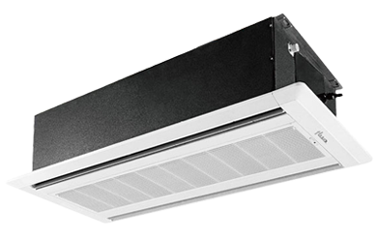

**Product Features**

* precise system control technology
* friendly referigerant R410a
* auto restart after power restored
* High Temperature Stable Running work upto 52C (T3 condition)
* Antifouling and Movable Baffle

**Specification**

**Type** Ceiling Cassette AC

**Cooling (Btu/h)** 34000

**Voltage (V)** 220-240

**Power Input (W)** 4900

**EER (Btu/W-h-W/W)** 7.3-2.9